**Problem 1:**

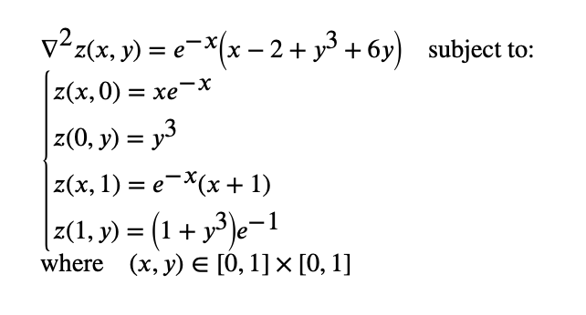

| Using Vanilla PINN:  Nf = 10000  Layers: 6 | Neurons: 15  Activation Function: Tanh  Iter 2997, Loss: 2.15934e-06, Loss_u: 7.11516e-07, Loss_f: 1.44783e-06  CPU times: user 45.5 s, sys: 1.25 s, total: 46.8 s  Wall time: 48.3 s  Error u: 1.627832e-02 |
| --- |

| Using TFC:  Layers: 6 | Neurons: 15  Nf = 100  Activation Function: Tanh  Iter 592, Loss_f: 1.68854e-07  CPU times: user 21.7 s, sys: 521 ms, total: 22.2 s  Wall time: 24.4 s  Error u: 6.769055e-06 |
| --- |

**Burgers 1D:**

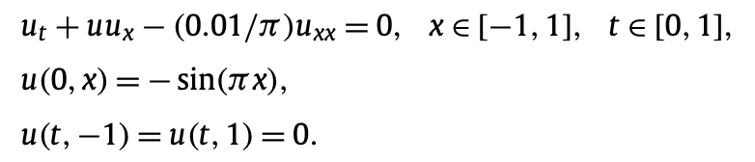

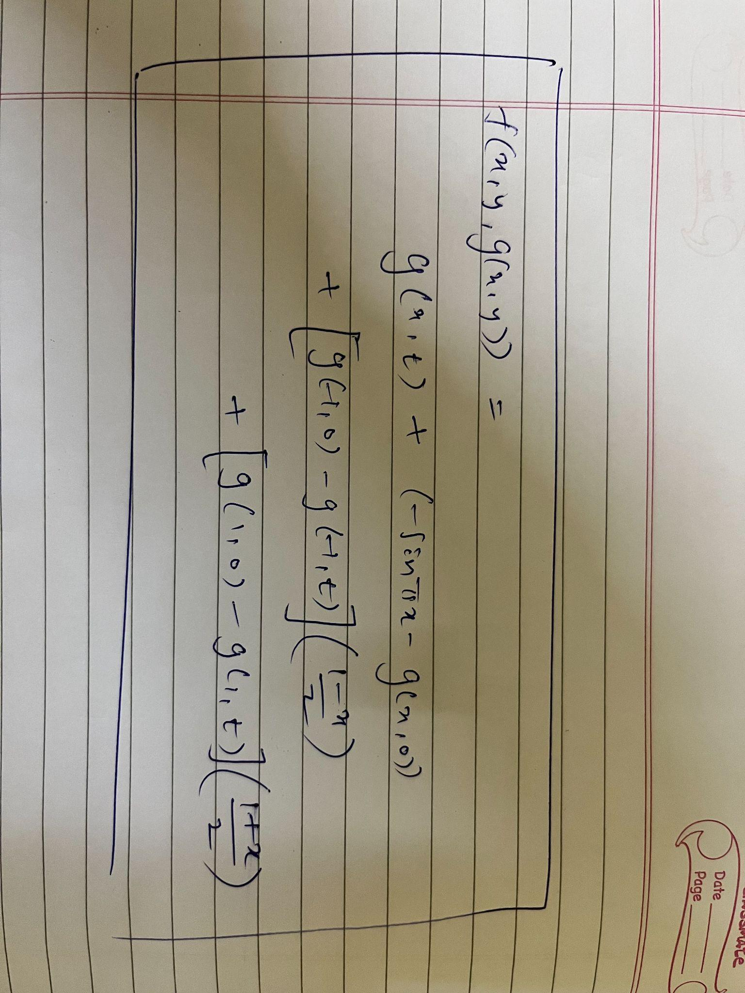

| Layers: 8 | Neurons: 20  Activation Function: Tanh  Nf = 1000  Iter 5748, Loss_f: 1.53718e-03  CPU times: user 3min 14s, sys: 1.97 s, total: 3min 16s  Wall time: 3min 19s  Test Error u: 1.336216e-01 |
| --- |

| Layers: 8 | Neurons: 20  Activation Function: Tanh  Nf = 10000  Iter 4394, Loss_f: 2.66567e-02  CPU times: user 2min 43s, sys: 1.79 s, total: 2min 44s  Wall time: 2min 48s  Error u: 7.048959e-02 |
| --- |

| Layers: 4 | Neurons: 30  Activation Function: Tanh  Nf = 1000  Iter 4211, Loss_f: 3.26178e-02  CPU times: user 1min 24s, sys: 1.25 s, total: 1min 25s  Wall time: 1min 25s  Error u: 1.307954e-01 |
| --- |